

**General Engineering Department**

______________________________________________________

Achilles Knee

**Project Requirements Specifications**

**Version 2.0**

**Project Team Members:** Eli Balidemaj, Vedant Desai, Lara Kurdi, Eddie Odera

**1. INTRODUCTION**

1.1 Purpose of Project

1.2 Background of the Experiment

**2.** **Requirements**

2.1 Physical Components

2.2 Software Components

**3.** **Procedures**

3.1 Physical Construction

3.2 Software Setup

3.3 Software Troubleshooting

**4****.** **Milestone and Final Product Requirements**

4.1 Benchmark A Requirements

4.2 Benchmark B Requirements

4.3 Final Submission Requirements

4.6 Human Resources and Training

**5****.** **Results**

5.1 Benchmark A Results

5.2 Benchmark B Results

5.3 Difficulties Experienced

**6****.** **Conclusion**

6.1 Results of Project

6.2 Future Improvements

**1. INTRODUCTION**

1.1 Purpose of Project

The purpose of the project is to report on the angle measurements of a Cricket athlete’s knee as a way to address the recurring issue of knee injuries that have happened to multiple players throughout recent years. Although cricket is a very popular sport across the world, these recurring knee injuries have yet to be addressed and are quite underrepresented. This allows for coaches to closely monitor their players and analyze the angle measurements provided to them through the use of angle sensors which gives them access to a Light-emitting Diode (LED) light to notify players of their faulty knee and leg placement. When a player goes beyond the ideal angle the LED will turn red and adjustments can be made by the coach to address this issue. This will occur during training and after many training sessions, the athlete is expected to have improved upon their leg placement to avoid the lokcing of the knee and reduce the amount of knee injuries that occur. Achilles Knee provides athletes with a more accessible, wearable technology for cricket coaches and athletes. If an athlete wants to increase their momentum and improve on their skill, and hence increasing the speed at which the ball moves, it would be ideal to have a knee brace and a coach who would be able to inform the player of this.

1.2 Background of the Experiment

For the technical aspect, the project’s hardware required one gyro sensor, one Bluetooth HC 05 module, Arduino UNO, Arduino nano, and a red LED. For the software, an app was built that would connect through to the LED using the Bluetooth. The angles would be displayed on the serial monitor using the gyro sensor. The coach would monitor the readings and the coach would turn the LED ON/OFF based on the athlete’s required form which is outlined by Cricket Australia. A braced knee could be helpful for both increasing momentum and preventing injuries. The braced position is usually noted at 180° and could change based on hyperextension.

**2.** **REQUIREMENTS**

2.1 Physical Components

The product, Achilles Knee, had the main components listed below and included two knee braces purchased from Amazon, as well as wiring materials provided by Open Lab.

Table 1: Physical Components of Achilles Knee

|  |  |
| --- | --- |
| **Components** | **Use** |
| Bluetooth | Connected to Achilles Knee app which connected to LED signal. |
| LED | Signals color (Red/Green) depending on the angle of the knee. |
| Knee Braces | Provide comfort for athletes as well as holding the sensor in place to get an accurate detection of knee movement. |
| Arduino Nano board  (Microcontroller) | Connects and powers the Gyroscope sensor. |
| Arduino Mega board (Microcontroller) | Connects and powers the LED light. |
| Gyroscope Vex Sensor | Detects and produces angle of athlete’s knee. |

The components were obtained in Open Lab and Amazon. Table 2 shows the cost estimate of the assembly of the Achilles Knee.

Table 2: Cost Estimate

|  |  |  |  |
| --- | --- | --- | --- |
| **Resource** | **Cost per unit** | **Commission** | |
| Quantity | Cost |
| Bluetooth Module | $13 | 1 | $13 |
| Padding | $8 | 2 | $16.99 |
| Projected Labor | $50 | 250 | $12500 |
| Miscellaneous | $130 | 1 | $130 |
| Total |  |  | $1, 2643 |
| **Total & 20% Slack** |  |  | **$15,172** |

2.2 Software Components

The programming language used was Arduino, and the IDE used was Arduino IDE. The microcontrollers used were Arduino Nano and Uno. Arduino was used because Arduino has a built-in analog-digital signal converter, which Raspberry Pi does not have. The function of the microcontrollers is to control the LED transmission as well as the data of the gyroscope which will allow for the coach to receive angle data as well as select which data is ideal or not.

The type of sensor used is a Gyroscope Vex sensor which transmits angular velocity. The angle had to be derived from the three angles provided by the sensor: X, Y and Z.

Sample code for the derivation of the angle from angular velocity as well as block code for the Achilles Knee app were used, modified and incorporated two programs to fit the device.

**3.** **PROCEDURE**

3.1 Physical Construction

The materials used were one gyro sensor, one Bluetooth HC 05 module, Arduino UNO, Arduino Nano, wires, 5V battery and LED. The angles would be displayed on the serial monitor using the gyro sensor. Preliminary sketches were created. Ideas and materials were discussed. Materials were purchased such as the knee padding and materials such as the gyro sensor, LED and the Arduino Uno and Nano boards were acquired from the open lab. Advanced 3D training was acquired to create CAD models using Fusion 360 although 3D printing did not occur since it was not necessary for the success of the final design. Initial CAD models were created for the original designs although opted out for a simpler and more cost-efficient design later on. The original design incorporated a calf brace as well as a case to hold the Arduino board and sensor. The original CAD models are presented below (Figures 1 -2).

Figure 1: Original CAD Model of Calf Brace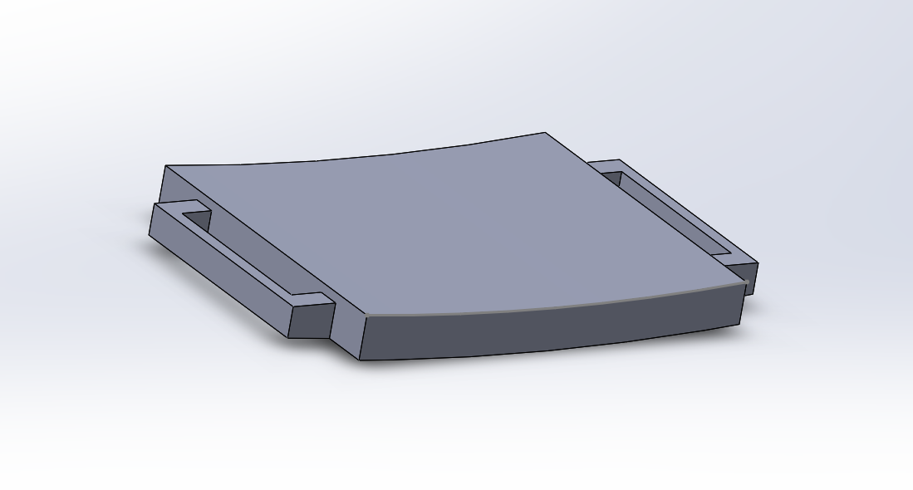

Figure 2: Top View of Original CAD Model of Calf Brace

When the knee brace was purchased, Velcro was used from the Makerspace to attach the sensor to the brace.

Using the circuit diagram (Figure 3) as a reference, wires were soldered onto the soldering circuit. All components were assembled on the knee brace to prepare for testing.

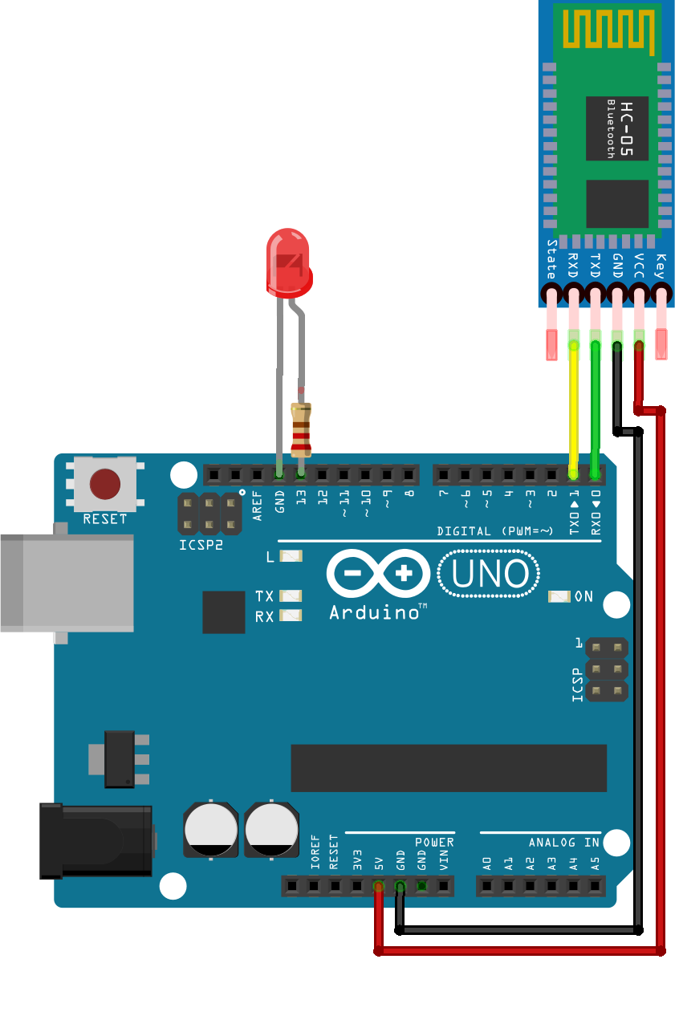

Figure 3: Circuit diagram with LED (Courtesy of NYU Tandon)

The gyro sensor would pick up the data and the Arduino nano would process the data and would display it on the serial monitor.

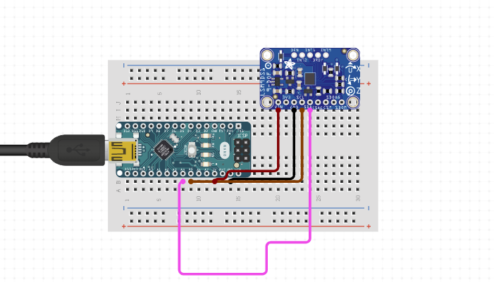

Figure 4: Circuit diagram with Gyroscope Sensor

3.2 Software Setup

Arduino IDE was used to code the functionality of the sensor. The flow chart was created. Then, the program was coded using the flowchart. The gyro sensor read the angle measurements the athlete's knee made and transferred that to the Arduino IDE screen made accessible to the coach and then the Achilles Knee app showcasing a screen with options to start, end, and turn on the Bluetooth were also made accessible. The concept is shown in the code flow chart below (Figure 5). 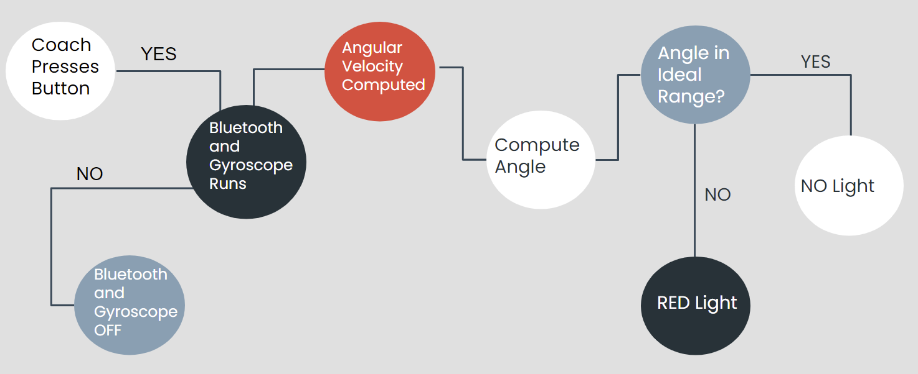

Figure 5: Code Flowchart

The Bluetooth modules used initially were HC 05 and HC 06 but to make it more accessible to the coach an app was built using block coding in MIT app inventor. The app would ask the user to select a Bluetooth device to connect to and then control the led to indicate an angle that was needed has been reached.

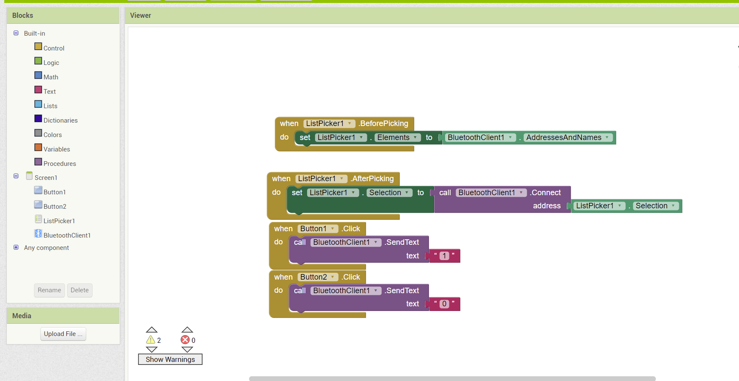

Figure 6: Block code for the app

A code was written for the LED to turn ON/OFF. The code was uploaded to the Arduino uno, the code used 1 and 0 to indicate ON and OFF.

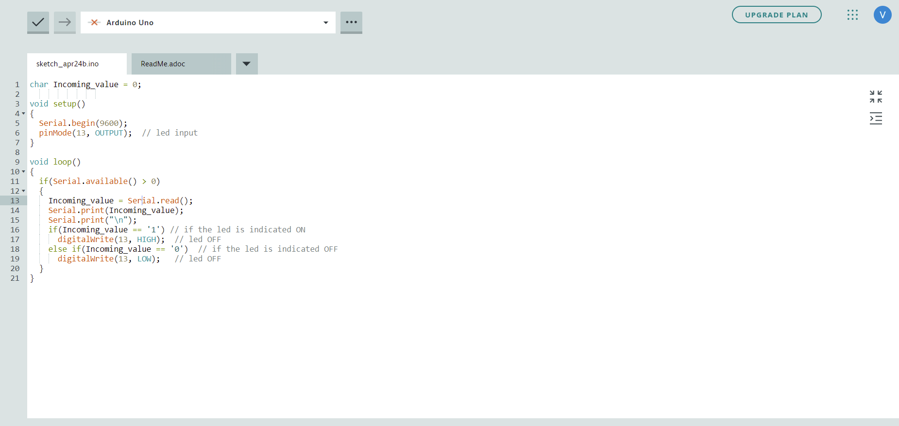

Figure 7: Code that controls the LED

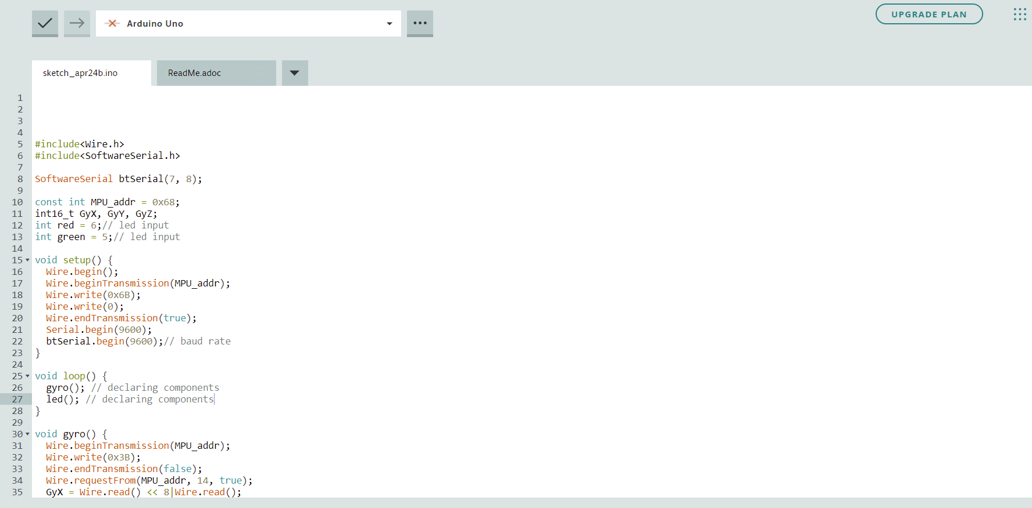

Figure 8: Transmission and gyro sensor code

The gyro sensor would get the data from the knee and get it across to an led that would receive the data via the Bluetooth module.

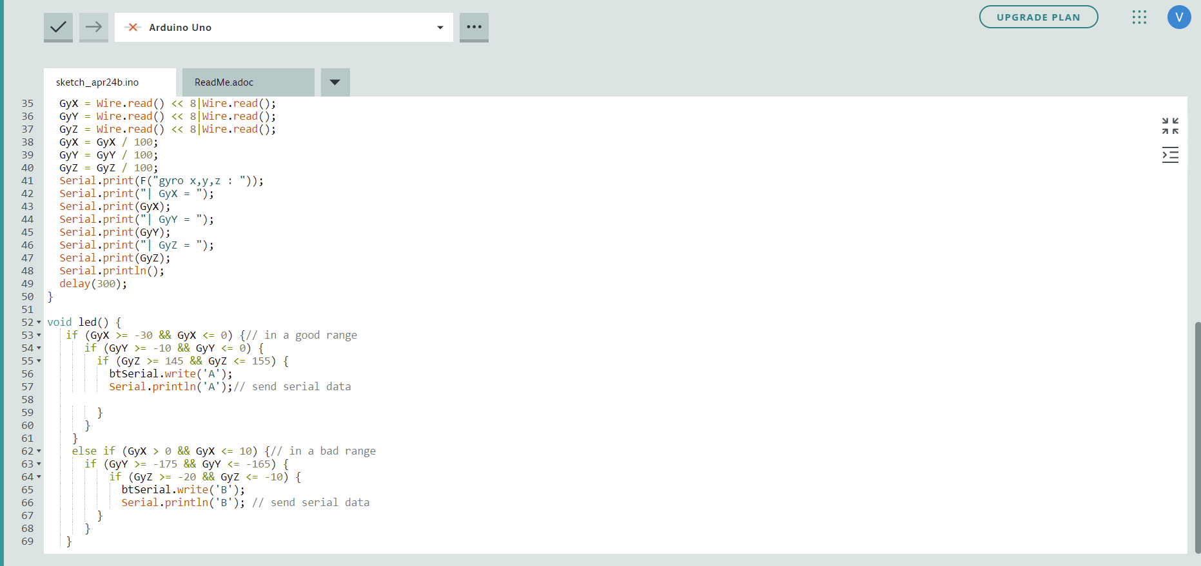

Figure 9: Code for the gyro sensor

3.3 Software Troubleshooting

The code for the gyroscope was run to ensure that the correct orientation of the gyroscope was formatted onto the breadboard. The Bluetooth module would send the data but the receiver would not receive it, because the Bluetooth modules would not go into AT mode. This resulted in using an app in lieu of two Bluetooth modules.

**4****.** **MILESTONE AND FINAL PRODUCT REQUIREMENTS**

4.1 Benchmark A Requirements

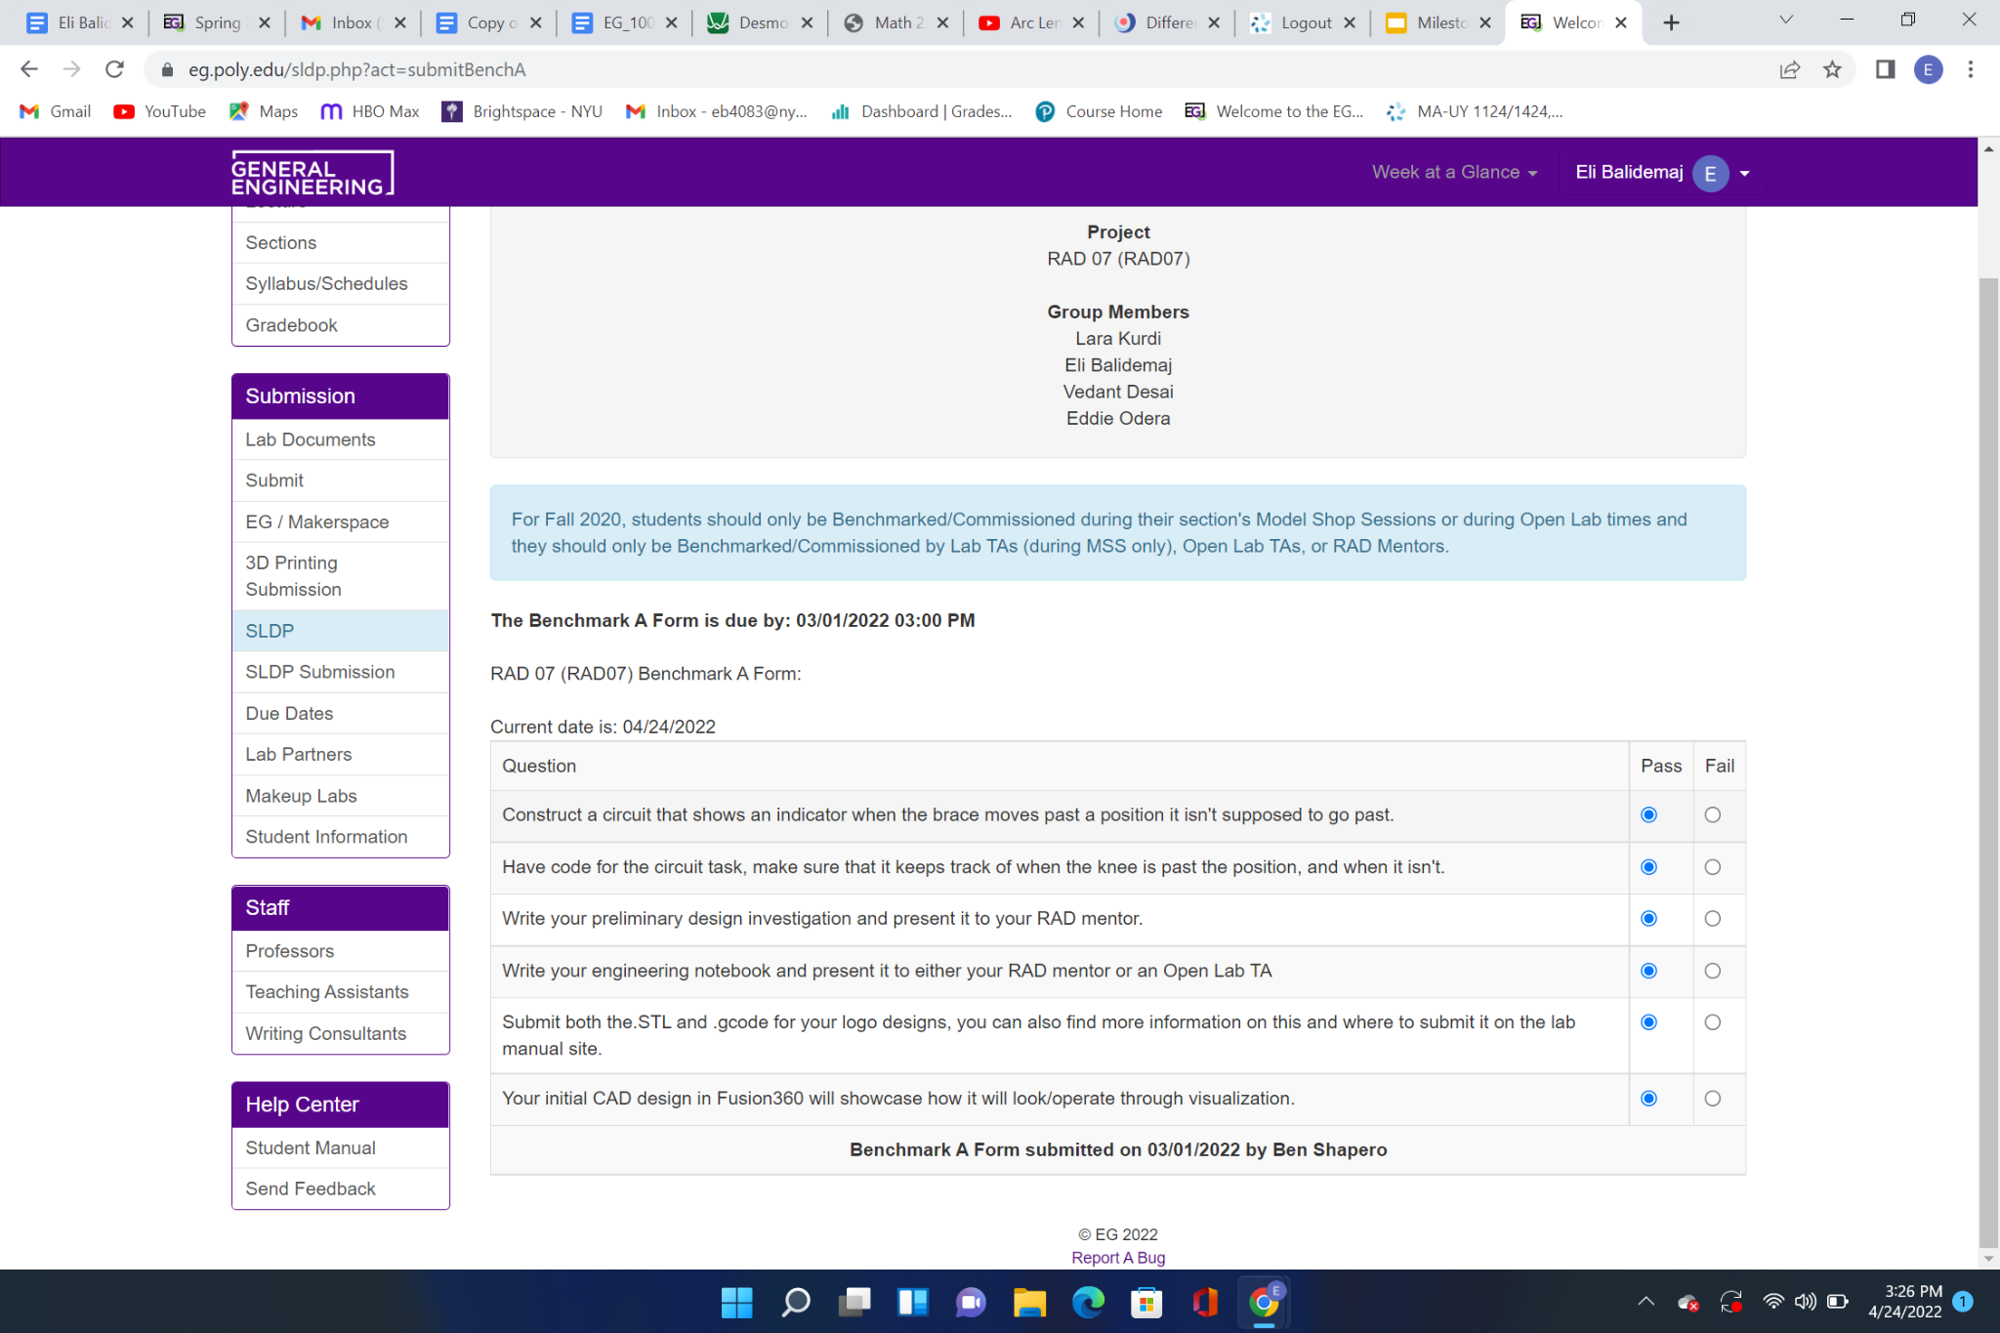

Figure 10: Benchmark A Requirements

4.2 Benchmark B Requirements

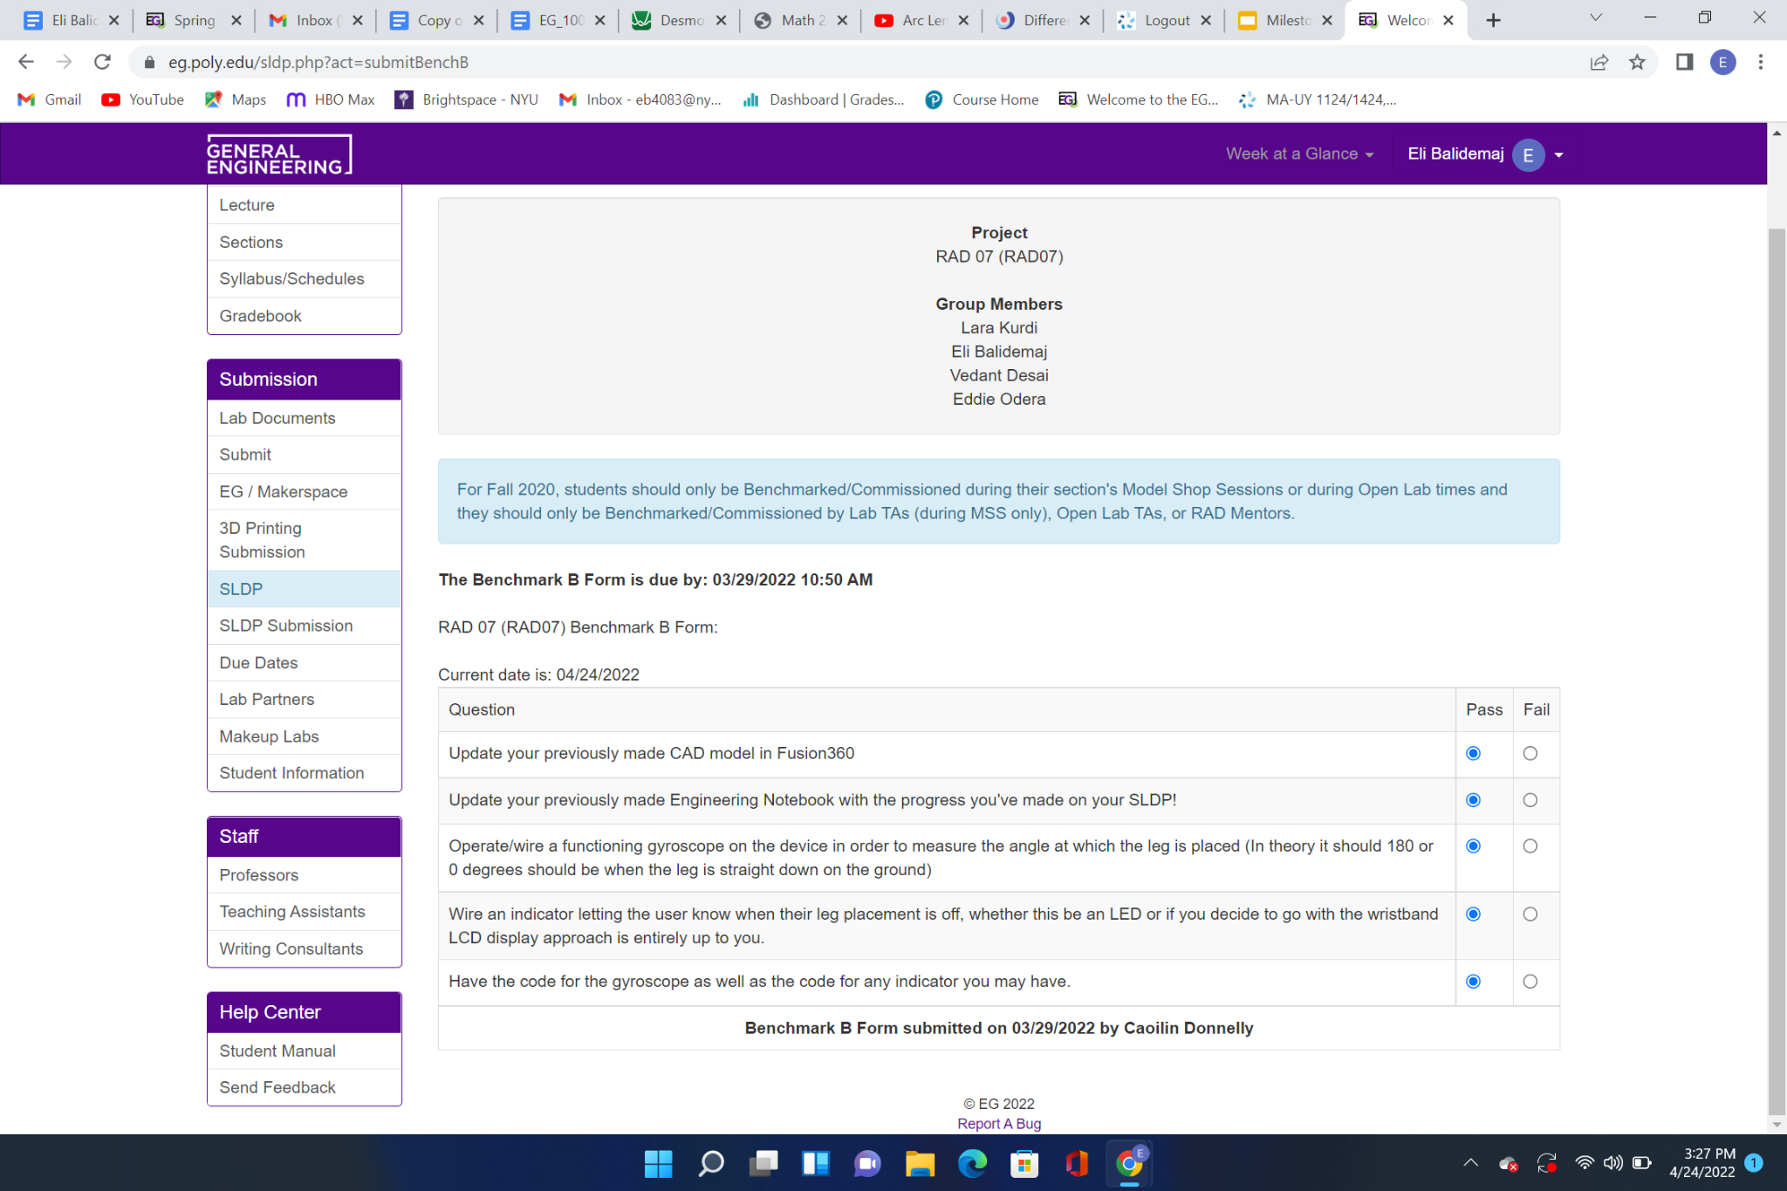

Figure 11: Benchmark B Requirements

4.3 Final Submission Requirements

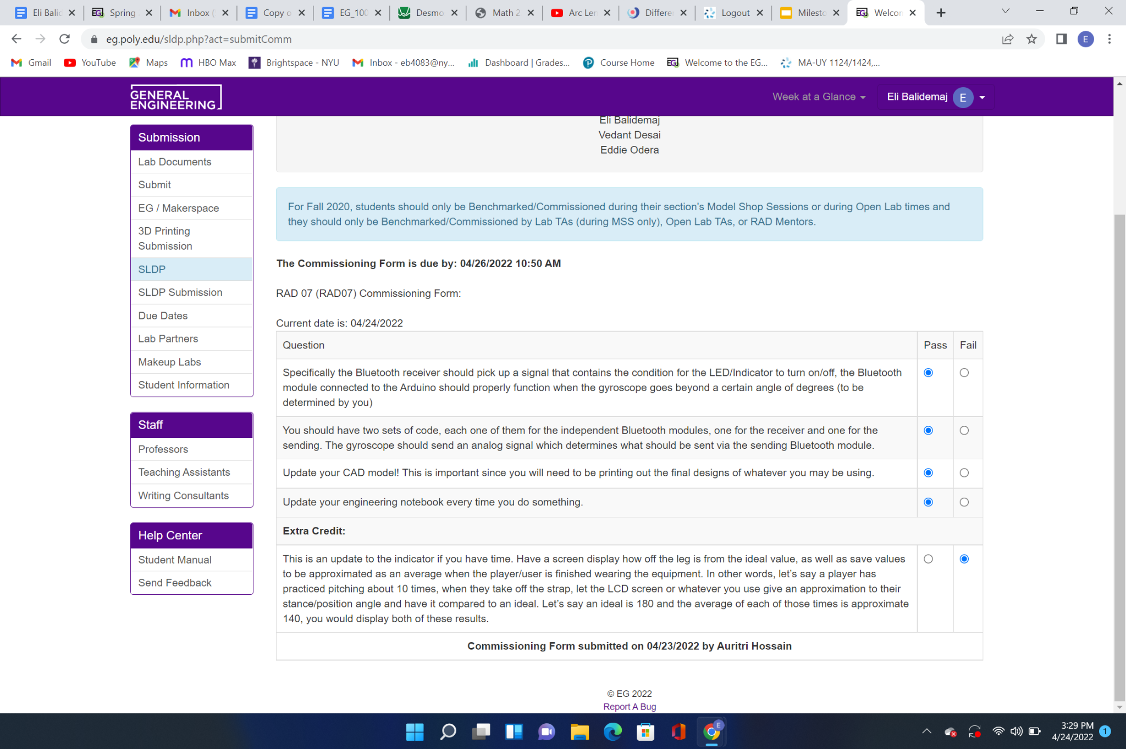

Figure 12: Final Submission Requirements

4.6 Human Resources and Training

All members succeeded in the NYU Makerspace training. All members had training for 3D printing provided by the Makerspace. Eddie received soldering training from Open Lab.

Figure 13 shows the schedule of the project.

**5****.** **RESULTS**

5.1 Benchmark A Results

Figure 13: Project Schedule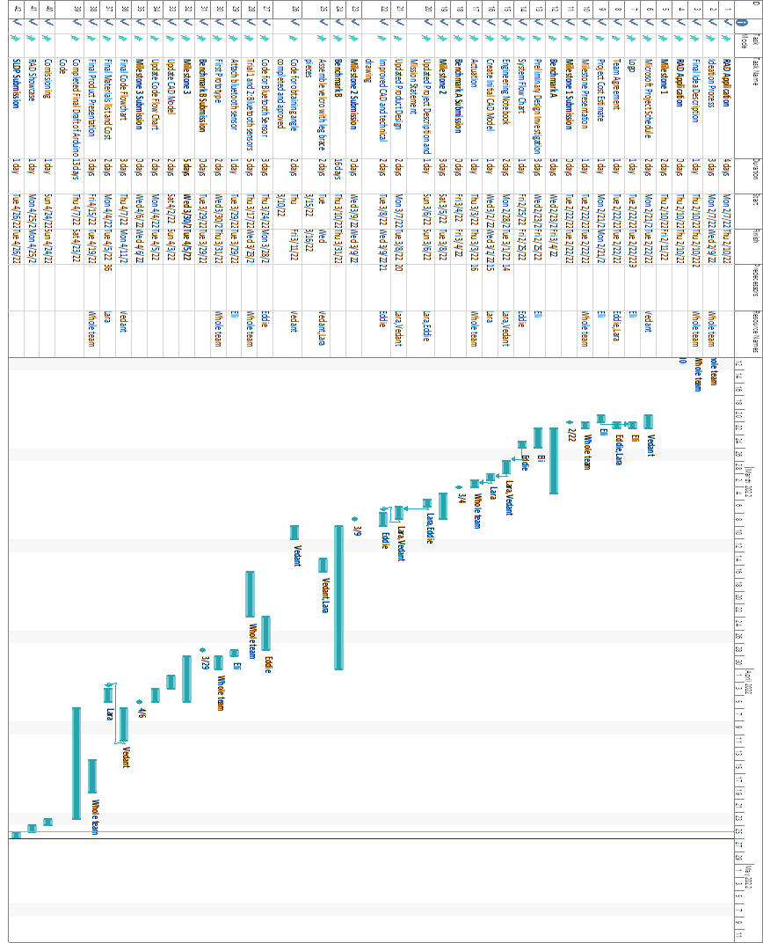

All benchmark A requirements were completed on time. The project was submitted in the standard submission time.

5.2 Benchmark B Results

All benchmark B requirements were completed on time. The project was submitted in the standard submission time.

5.3 Difficulties Experienced

In the coding aspect, the Bluetooth module would not go into AT mode, which helps in changing the settings of the Bluetooth module that is changing it into master or a slave. The Bluetooth slave was not picking up the data sent from the master Bluetooth module. To counter the difficulties an app was built to send the data and control the LED.

**6****.** **CONCLUSION**

6.1 Results of Project

The final product was prototyped successfully. The product functioned with the use of an app that was built by block coding with the use of MIT app inventor. The app would send a signal to the Bluetooth to turn it on and off as per the coach’s instructions. The gyro sensor would pick up the data off the athlete’s knee position and display it on the serial monitor. The serial monitor would display all the angle changes in the knee’s position namely X, Y,Z. The X angle displayed the extension of the feet and the Y and Z coordinate would help in determining the twisting of the foot. The product would function as an optimal training device for an athlete to train in the cricket nets with his coach. The final product satisfied the requirements for all Benchmarks as well as the commissioning.

6.2 Future Improvements

The prototype could be improved by expanding the project to detect the form of the athlete’s back in addition to the knee. This would allow the athlete to focus on his overall form instead of just his leg movements. Another improvement would be altering the device to allow the athlete to determine whether his form is acceptable without the coach monitoring the data and pressing the button. The LED would light up on its own when the data is not within the acceptable range, and the athlete would observe the results from the LED and adjust accordingly.